Analgesics and Antipyretics
Acetaminophen 500mg tablets
Ibuprofen 200mg tablets**
Ibuprofen 800mg tablets**
Naproxen 500mg tablets**
Antibiotics
Amoxicillin 500mg capsules
Azithromycin 250mg tablets (aka Z-pak)
Ceftriaxone 250mg IM injection (STI only)
Cephalexin 500mg capsules
Ciprofloxacin 500mg tablets**
Doxycycline 100mg tablets
Metronidazole 250mg tablets
Nitrofurantoin 100mg capsules *Must meet criteria pg2*
Sulfamethoxazole/Trimethoprim 800mg/160mg tablets
Antifungals
Fluconazole 150mg tablets
Antihistamines/Allergic Rhinitis
Diphenhydramine 25mg capsules
Loratadine 10mg tablets
Fluticasone (Flonase) Nasal Spray
Antivirals
Acyclovir 400mg tablets
Arthritis
Diclofenac Gel 1% (100g/tube)**
Asthma/COPD
Albuterol sulfate HFA 90mcg/actuation inhaler (18g)
Albuterol Sulfate 0.083% (2.5mg/3mL) inhalation solution
Fluticasone/Salmeterol inhaler113mcg/14mcg
Fluticasone/Salmeterol inhaler 232mcg/14mcg
Incruse Ellipta (umeclidinium) 62.5mcg/inhalation
Qvar RediHaler (beclomethasone dipropionate HFA) 40mcg/actuation
Qvar Redihaler (beclomethasone dipropionate HFA) 80mcg/actuation
Stiolto Respimat (tiotropium/olodaterol) inhaler
2.5mcg/actuation
Striverdi Respimat (olodaterol) 2.5mcg/actuation
Benign Prostatic Hyperplasia
Tamsulosin 0.4mg capsules
Cardiovascular disease risk reduction
Aspirin 81mg EC tablets
Cough/Cold/Congestion
Guaifenesin 100mg/5ml syrup (118ml)
Dextromethorphan (DELSYM) 30mg/5ml syrup (89ml)
Corticosteroids (oral)
Prednisone 10mg tablets
Prednisone 20mg tablets

Diabetes Mellitus
Glipizide 5mg tablets
Glipizide 10mg tablets
Metformin 500mg tablets
Metformin 1000mg tablets
Insulin Lispro 100 units/mL (3 mL)***
Insulin Glargine 100 units/mL (3 mL)***
Gastrointestinal
Docusate Sodium + Senna 50mg/8.6mg tablets
Docusate Sodium 100mg capsules
Loperamide 2mg capsules
Omeprazole DR 20mg capsules
Famotidine 20mg tablets
Simethicone 125mg tablets
Hypercholesterolemia
Rosuvastatin 5mg tablets
Rosuvastatin 20mg tablets
Hypertension/Diuretics
Amlodipine 5mg tablets
Amlodipine 10mg tablets
Hydrochlorothiazide 25mg tablets
Furosemide 40mg tablets
Labetalol 100mg tablets ** for pregnancy only**
Lisinopril 5mg tablets
Lisinopril 10mg tablets
Lisinopril 20mg tablets
Lisinopril 40mg tablets
Losartan 25mg tablets
Losartan 50mg tablets
Metoprolol succinate 25mg tablets
Metoprolol succinate 50mg tablets
Spironolactone 25mg tablets
Insomnia
Melatonin 5mg tablets
Muscle Spasms
Cyclobenzaprine 10mg tablets
Oral Contraceptives (28 tablet packs)
Aubra 0.1/0.02mg (levonorgestrel/LD estrogen combo)
Norethindrone 0.35mg (progestin only)
Previfem/ Vylibra/Estarylla 0.25/0.035mg (Norgestimate /estrogen combo)
Ophthalmology
NaphconA (Naphazoline 0.025%, Pheniramine 0.3%)
Lubricant eye drops (15 ml)
Psychiatric
Bupropion XL 24-hour 150mg tablets
Duloxetine DR 30mg capsules**
Duloxetine DR 60mg capsules**
Escitalopram 10mg tablets**
Fluoxetine 20mg capsules**
Hydroxyzine HCl 25mg tablets

Skin and Mucous Membranes
Carbamide peroxide 6.5% ear drops (15mL/vial)
Clobetasol 0.05% topical cream (30g/tube)
Clotrimazole 1% cream (28g/tube)
Hydrocortisone 1% cream (28g/tube)
Hydrocortisone 2.5% cream (28.35g/tube)
Hydrocortisone 2.5% ointment (30g/tube)
Nasal saline 0.65% (1.5 fl oz)
Permethrin 1% cream rinse (2 fl oz/bottle kit) [aka Nix]
Triamcinolone acetonide 0.1% cream (28g/tube)
Triple Antibiotic ointment (28g/tube)
Neurology
Propranolol 20mg *can only be prescribed by neuro clinic*
Sumatriptan 50mg
Topiramate 50mg *can only be prescribed by neuro clinic*
Smoking Cessation
Nicotine 2mg sugar-free gum
Nicotine 4mg sugar-free gum
Nicotine 7mg patches
Nicotine 14mg patches
Nicotine 21mg patches

Common “Non-Formulary Request Medication” examples (see below for process)
- Levothyroxine
- Rhogam
- Fluoxetine 10mg

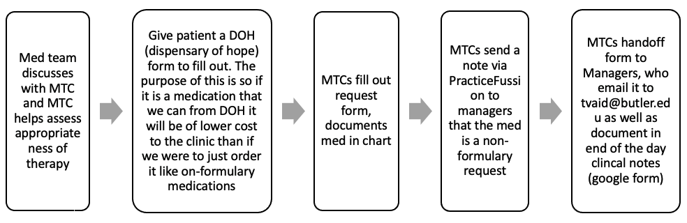

Vitamins/Supplements
Multi-vitamins (adult) tablets
Prenatal Vitamin tablets
Ferrous sulfate (65mg elemental iron) 325mg tablets
Potassium Chloride 10mEq tablets
Miscellaneous
Clonidine 0.2mg tablets (Emergency Only – Hypertensive)
EpiPen 0.3mg injection pen (Emergency Only – Anaphylaxis)
Nitroglycerin 0.4mg SL tablets (Emergency and prescription use)
Glucose tablets (Emergency Only – Hypertensive)
Ketorolac Injection
Sterile Water for Injection
Lidocaine 1% Solution for Injection
Hydrogen Peroxide solution

**Criteria for Nitrofurantoin for UTI use:
Bactrim preferred unless:
Sulfa allergy
CrCl <50ml/min (can use nitrofurantoin if CrCl >30)
Pregnancy
Recurrent UTIs or failed Bactrim therapy
Past susceptibility reports of Bactrim resistance

