ACEI 3.1 Integrating and Applying Knowledge for Instruction
Visual Evidence
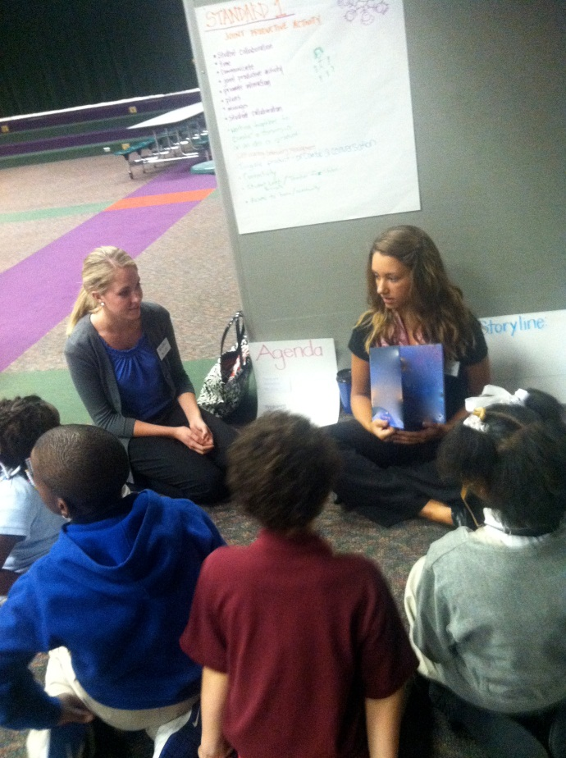
This is our instruction and introduction of Joe Louis: America’s Fighter. Before we started, we asked the students what made a person famous. We then asked what books are called when they are written about a famous person. One of the students knew the word “biography” and another came up with “autobiography”. We wrote down on a poster the breakdown of the word and the definition of the roots in autobiography to help the students understand the origin of the word .

Learning Theories
The learning theory Lauren and I believed would be most beneficial to the students was using the Optimal Learning Model. In this lesson, our goal was to have the students understand what a biography and autobiography is and be able to create their own. We started by reading a biography to the students and showing them the important facts and events the book lists. We then had the students tell us important facts in their lives with us helping the think of the basic facts about them. The students then wrote their books with our assistance if needed. Then the students shared their autobiographies and why they included those pieces of information. I believe using this learning model made the lesson more engaging and memorable for the students so they will have an experience to connect to a topic.

Knowledge of Students
At this point in time, we knew our students very well, as we had spent 7 other enrichment hours with them.
- Riyan- Riyan was always excited to see what activities we had planned for the lesson. Sometimes she wasn’t always as interested in the story we read, but she worked diligently on the writing and drawing portions of our lessons. Unfortunately, Riyan was not present for this lesson, but we would have loved to see her work with this. She is very creative and has an amazing imagination.
- Jamir- Jamir is one of the most courteous students we had this semester. He is always excited to participate and wants to respond to all of our questions, even when he isn’t sure of the answer. He was especially interested in Joe Louis because his brother wrestles and he connected this to boxing.
- George- George probably had the most energy out of anyone in our group. Sometimes keeping his excitement down to an appropriate level was a challenge, but we were so glad to have a student that could get the other students enthused. George was another creative student we had who brought new ideas and inspiration to our group, and especially to Lauren and I.
- Naamond- Naamond was amazing at making connections to daily life and other topics or ideas that I would normally not have thought of. I learned so much from Naamond this semester through his comments and opinions he shared. Naamond also challenged Lauren and I to adapt our lesson plans to his special needs. A large part of my professional growth can be accredited to finding a successful method of instruction and assessment for Naamond.
- Aanaiah- Aanaiah was one of the students that always came to our sessions with a huge smile on her face. She is a very witty girl who loves to draw. Aanaiah could always cheer up other students and show compassion.
- Omatola- Omatola was only able to be in our group for the last two days of enrichment. Her focus is absolutely incredible. She is so driven, and I believe the students feed off of her commitment to a task. She was truly a pleasure to have with us even though it wasn’t for long.
Community
The students we worked with for this lesson are third graders in Loving Care. Loving Care is an afterschool program for students at Central Elementary School. Central has a student population that is 64% Black, 19% Hispanic, 7% Multiracial, 7% White, and 2% Asian. Of these groups, 75% of the students participate in free or reduced lunch. This school also has 17% of the students enrolled in special education and 25% of the students are English Language Learners. Our plans reflected preparing for their contextual needs because our focus for this lesson was on African American culture by discussing the life of Joe Louis. All of the students in our group thoroughly enjoyed the story and I believe this could be an explanation for why they were more interested in the topic.
Subject Matter & Appropriate Curricular Standards for Learners
The standards we chose to focus on for this lesson on biographies and autobiographies were:
-EL.3.3.1 2006
Structural Features of Literature:
Recognize different common genres (types) of literature, such as poetry, drama, fiction, and nonfiction.
Example: Look at the same topic, such as cranes, and see how it is shown differently in various forms of literature, such as the poem "On the Run" by Douglas Florian, the play The Crane Wife by Sumiko Yagawa, Anne Laurin's fictional book Perfect Crane, and the nonfiction counting book Counting Cranes by Mary Beth Owens.

-EL.3.4.2 2006
Discuss ideas for writing, use diagrams and charts to develop ideas, and make a list or notebook of ideas.

We chose these standards at their grade level, and because we knew the students prior to this enrichment session, we could better plan for what we would be able to accomplish with the students. By allowing them to choose from the biographies we had, the subject matter was specifically planned according to the students’ interests.
Planning
-See Lesson Plan 1
Reflection
The level of engagement shown by the students during this lesson was phenomenal. I believe this is because the students were given a choice in the story that was read to them. Lauren Prop and I also implemented some behavior management strategies during this lesson as a result of how our previous days had gone with these students. This is one of the moments where I completely understood how many problems a teacher has can be solved by using another strategy. Many of my professors tell us that a problem in the classroom is usually due to something the teacher is or is not doing. Simply assigning the students their seats and facing the students toward the wall solved a lot of our issues we were having.
This lesson also gave us an opportunity to practice talking about sensitive issues with younger students. Since Joe Louis’ story mentions being oppressed racially, we had a short discussion about why that was common for that day and age. The students responded so well to this conversation that I am no longer afraid to discuss these matters in my own classroom with a large group of students. Before this lesson, I thought a discussion like this would be complex and possibly lead to upset students. This group showed me how mature third graders can be regarding social issues. I am so thankful for such an opportunity to come so early in my teaching career.
I don’t think I would have done much differently with this lesson. My only wish would be that we would have more time with the students so I could discuss the topic more in depth with them.
ACEI 3.2 Adaptation to Diverse Students
Lessons Appropriately Planned
Being our second enrichment session at Central Elementary, we knew generally what to expect from this group of students. We had the same group of third grade students for this session, with the addition of one more female student. Lauren Prop and I planned this lesson to follow the Common Core Standards for third grade English and Language Arts. We knew the students needed a hands-on activity during our instruction that would hold the students’ attention in a loud cafeteria. Reflecting back on the past activities we did with the students in the first enrichment session, we were able to create a lesson based on the interests of the students.
Materials and Rationale
The book we selected for this lesson was actually chosen by the students because Lauren and I wanted to make sure the student’s had a choice of what they were learning. The content we chose to focus on for this enrichment session was biography studies. After sharing one biography with the students, we gave them a choice between three other biographies. After seeing the students’ interest in Joe Louis: America’s Fighter, we chose that book. We also knew the students love opportunities to be creative. During the last session, the student’s told us they wanted to color, draw, and write, so we made sure to have materials and activities for this incorporated into our lesson plan. We also had a student with special needs in our group who loved to color and draw, but his strength was not in writing. We made sure the tasks and materials presented would allow Naamond to participate. Specifically, the students were asked to write an autobiography, so the option was given to draw his autobiography instead of write about it. He did choose to write a short summary on each page by asking me how to spell the words he didn’t know how to write. Having colored pencils, markers, and booklets allowed Naamond to participate and not feel inferior or different from the other students in our group.
Methods
As previously stated, Lauren and I provided various methods of participation for the students due to the needs of our learners. We noticed that Naamond had a difficult time expressing his thoughts clearly, and sometimes did not understand a question if it was too long. When asking a question to guide the students through the story, we made sure that our questions were clear and concise. We also gave praise and positive feedback to every appropriate answer given. We wanted to show the students that we valued each student’s ideas and opinions.
ACEI 3.3 Development of Critical Thinking, Problem Solving, Performance Skills
We started off this enrichment session by reading examples of biographies. We asked the students if they knew what a biography was, and using that knowledge, what is an autobiography? We also discussed what makes a person famous and asked for examples of famous people.
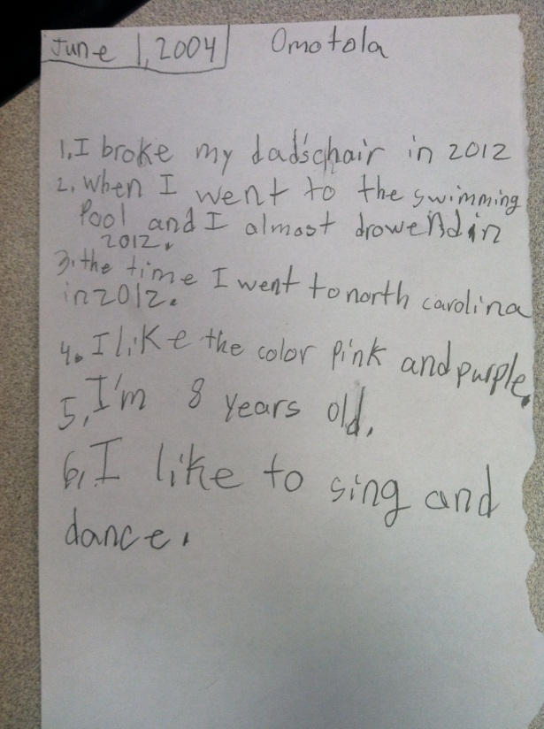
We invited the students to think of the biography books we read and decide what information they all had in common. We asked, “What are some things you would want readers to know about you? Write them down on your planning sheet. You might want to start with the day you were born.” This was Omatola’s planning sheet for her autobiography. We used the book Joe Louis as a reference. It was especially helpful because it contained a timeline and interesting facts at the end of the story. The students understood what is important to include in an autobiography.

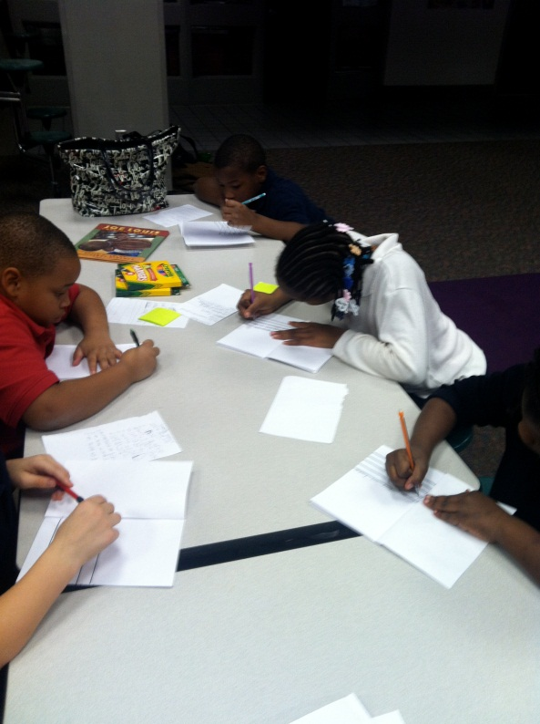
The students set to work on their autobiographies after planning. We gave them pre-made booklets with lines for writing for the sake of time. There was room on each page for an illustration as well. This helped the students feel like authors and writers.
These are finished writing samples from the students. They were asked to create their own title after given Lauren’s example of the book, “The Life of Ms. Prop.” On the inside, events go in chronological order with some interesting facts about each student. The students now showed complete understanding of biographies versus autobiographies.
