

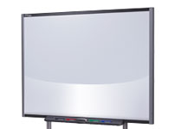

Contents
Introduction 3
Using SMART Boards 3
Learning Outcomes 3
Performance Objectives 3
SMART Board Locations 3
Getting Started 4
Displaying Content 4
Single Monitor Projection 4
Dual Monitor Projection 4
Other Sources 4
Calibrating the SMART Board 5
Whiteboard 5
Interacting with the Board as a Mouse 5
The Floating Tools Toolbar 5
Using the Digital Ink 6
Using SMART Board with Other Applications 6
Inserting Notes into Microsoft Word 6
Adding Images 6
Adding Text 6
Inserting Notes into Microsoft Excel 7
Adding Images 7
Adding Text 7
SMART Board and Microsoft PowerPoint 7
Screen Captures and SMART Notebook 8
More Information 8
Bibliography 8
Creative Commons Licensing 9

Introduction

Using SMART Boards
This training document will help you use and calibrate a SMART Board.

Learning Outcomes
As a result of the SMART Board training, you will be able to:
- Give reasons why SMART technology is beneficial in the educational environment
- State the areas where SMART Boards are located at Butler University
- Use SMART Boards to facilitate class activities
- Reflect on your use of SMART technology and steps to increase use

Performance Objectives
Upon the completion of this training, you will be able to:
- State examples from case studies of other universities and secondary schools in which SMART technology benefited learning
- List the classrooms and labs that contain SMART Boards
- Use a projector to display your computer monitor
- Use the SMART Board as a whiteboard
- Calibrate the SMART Board
- Interact with the touch screen as a mouse
- Annotate and draw on the SMART Board over documents, web pages, and presentations
- Convert annotations to text and drawings to objects and insert into Microsoft Office applications
- Take a screen capture that saves in SMART Notebook
- List two new ways SMART Boards can be used to enhance your teaching
No previous experience is required for this training. This document will cover the basics of the SMART Board and will benefit new users to SMART Boards.

SMART Board Locations
Butler University currently has SMART Boards in the following classrooms:
- HB 122 (4)
- HB 231
- HB 235 (3)
- HB 109 (1)
- JH 041 (2)
- JH 043 (2)
- JH 220
- PB 150 (2)
- PB 153
- PB 156 (2)
- PB 309

Getting Started

Displaying Content
Content can be displayed on the screen in your classroom from several sources, including the instructor workstation, instructor laptop, and Doc Cam.

Single Monitor Projection
Complete the following steps to display your monitor on the SMART Board.
- Turn on and login to the workstation.
- Select the source of projection on the mounted AMX touch panel. For example, PC to display the instructor workstation.
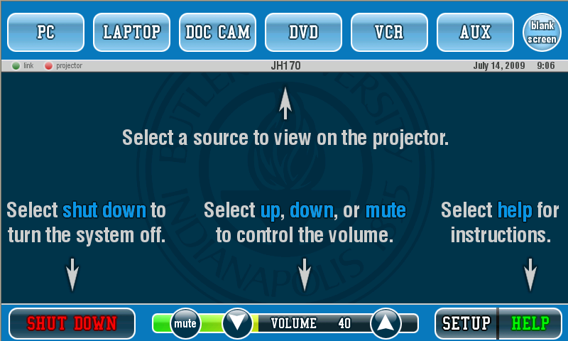
- If your classroom has multiple screens, you will need to select the screens to display the monitor. Select All Displays to show the monitor on all screens, or select the screens you wish to use.

Dual Monitor Projection
If working on a dual monitor computer, you can display either monitor or both monitors if you have multiple screens.
To display one monitor,
- Select the monitor on the left hand side of the touch panel.
- Press the All Displays button.
To display both monitors,
- Select the Left Monitor.
- Select the desired display(s).
- Select the Right Monitor.
- Select the desired display(s).

Other Sources
Besides displaying a computer monitor, you can display other sources. Follow the steps for the Single Monitor Projection above, but select the desired source instead of PC.

Calibrating the SMART Board
SMART Boards will occasionally need to be calibrated to ensure that the board recognizes your touch accurately in the correct place. To calibrate the SMART Board,
- First press both buttons (mouse and keyboard) located at the bottom of the SMART Board.
- Nine targets will appear on the screen.
- Pick up a pen or use your finger and press the tip to the center of each target.
- The SMART Board is now calibrated. Write on the screen to test the calibration.

Whiteboard
In addition to using the SMART Board to project your monitor, you can use the SMART Board as a whiteboard.
- Follow the display instructions above to display your monitor.
- Open Microsoft Word or SMART Notebook.
- Use the white space in these applications as your whiteboard. To save notes, complete the instructions below in the “Using SMART Board with Other Applications” section.

Interacting with the Board as a Mouse
Besides serving the function of a marker board, SMART Boards also act as a touch screen. This allows you to navigate through applications at the touch of a finger, without moving back and forth from computer to board. To interact with the SMART Board,
- Use your finger as a mouse. Double click on an application to open it.
- You can use your finger to perform other mouse functions, including clicking once to follow links and pressing and dragging scroll bars to navigate down a page.

The Floating Tools Toolbar
The Floating Tools toolbar allows you to change your finger from a mouse cursor to a variety of tools. Using the Floating Tools, you can write, highlight, erase, and right-click on the board.
- If the Floating Tools toolbar is not already open, click the SMART Board icon at the bottom right of your screen and select Show Floating Tools.
- Select the tool you wish to use. Note that many applications open the Digital Ink Layer that overlays other applications.
Cursor
Pen Tool

Area capture
Undo/Redo
Right-click
Eraser
More
Highlighter

- To right-click, select the right-click mouse from the Floating Tools. Only your next press will be a right-click.
- To return the cursor to mouse mode, click the black arrow from the Floating Tools.

Using the Digital Ink
The SMART Board pens are unique compared to regular markers because they write in digital ink. The SMART Board recognizes each pen by a light sensor in each of the pen trays. If the light sensor is covered up, SMART Board assumes the pen is in the tray. SMART Board does not recognize the pen color by the pen you place to the board; it recognizes the last pen picked up. For example, if you pick up the black pen and annotate over a presentation, the digital ink will be black. If you then pick up the red pen but decide to write with the black pen, the digital ink will be red because that was the last color SMART Board recognized. Additionally, SMART Board recognizes any touch to the board, so you can use either the pen or your finger to write on the board.
To write with digital ink:
- Pick up a pen. The Digital Ink Layer will open, allowing you to write over any open application.
- You can make notes anywhere on the board using the pen.
- To erase notes, pick up the eraser and touch it to the digital ink you wish to erase. Return the eraser to the tray.
- Continue annotating on the board.
- When your notes are complete, you have the option to save or close the ink layer.
  - To save, press the Screen Capture button at the top of the Digital Ink Layer.
  - SMART Board will import the screen capture to SMART Notebook. Save the file.
  - To close the Digital Ink Layer, press the red X in the upper right corner of the screen.

Using SMART Board with Other Applications
You can insert digital ink into applications when the applications are Ink Aware. Microsoft has Ink Aware applications, including Word, Excel, and PowerPoint.

Inserting Notes into Microsoft Word
Notice the SMART Aware toolbar under the regular Word toolbars. You will be using these tools to add annotations to your documents.

Adding Images
- Create your image using the pen tool to draw with digital ink.
- Press the Insert Drawing as Image button to convert your digital ink to an image and insert it into your Word file.

Adding Text
- Click and move your cursor to where you wish to add text.
- Use the pen to write the desired text. The text will appear in the same font color as the digital ink.
- Click the Insert Drawing as Text button to add the text to the file.

Inserting Notes into Microsoft Excel
Notice the SMART Aware toolbar under the regular Excel toolbars. You will be using these tools to add annotations to your documents.

Adding Images
- Create your image using the pen tool to draw with digital ink.
- Press the Insert Drawing as Image button to convert your digital ink to an image and insert it into your Word file.

Adding Text
- Click the cell where you wish to add text.
- Use the pen to write the desired text. The text will appear in the same font color as the digital ink.
- Click the Insert Drawing as Text button to add the text to the file.

SMART Board and Microsoft PowerPoint
SMART Board offers a variety of functions to PowerPoint. Notes can be added directly to a PowerPoint presentation and either saved or cleared.
- Open your presentation and begin the slideshow.
- Navigate through the presentation using the forward and backward arrows on the Slide Show toolbar.
- To annotate over the presentation, pick up a pen from the tray and write directly on the screen. Return the pen when finished.
- To clear the annotations, press the SMART Board once with your finger.
- To save the annotations in the presentation, press the center button on the Slide Show toolbar and select Insert Drawing as Image.
- To leave the slide show, press the center button on the Slide Show toolbar and select End Show.
- Save the file if any changes were made.

Screen Captures and SMART Notebook
You can take a screen capture to save your notes anytime while using SMART Board. All screen captures are immediately imported into SMART Notebook.
- Any time the Digital Ink Layer is open (i.e. when a pen is active), you have the option of capturing the screen. This can be used when a webpage or other application is open.
  - Press the Screen Capture button in the upper right corner of the Digital Ink Layer.
  - The screen capture will be added to a SMART Notebook file.
  - Save the SMART Notebook file.
- Screen captures can be taken in Microsoft Word and Excel.
  - Press the Screen Capture button in the SMART Aware toolbar.
  - The screen capture will be added to a SMART Notebook file.
  - Save the SMART Notebook file.
- To take a screen capture in Microsoft PowerPoint,
  - Click the center button on the Slide Show toolbar and select Capture to Notebook.
  - The screen capture will be added to a SMART Notebook file.
  - Save the SMART Notebook file.

More Information
SMART has great training resources located on their website, http://www.smarttech.com. Click the training tab for tutorials and training references.
For access to additional information, tutorials and workshops, please visit the Instructional Technology website, http://www.butler.edu/ir/it or contact Instructional Technology staff member at training@butler.edu.

Bibliography

"Orienting Your Board." SMART Technologies. Ed. SMART. Web. 10 Dec. 2009. <http://downloads01.smarttech.com/media/trainingcenter/flash/orienting_your_board/orienting_your_board.htm>.
"Quick Reference: The Floating Tools Toolbar." SMART Technologies. Ed. SMART. Web. 10 Dec. 2009. <http://downloads01.smarttech.com/media/services/quickreferences/pdf/english/
qrnb10floatingtoolbar.pdf>.
"A Two-Minute Tutorial: Microsoft PowerPoint and The SMART Board Interactive Whiteboard." SMART Technologies. Ed. SMART. Web. 10 Dec. 2009. <http://downloads01.smarttech.com/
media/trainingcenter/flash/powerpoint.htm>.
"A Two-Minute Tutorial: Touch, Write and Save." SMART Technologies. Ed. SMART. Web. 10 Dec. 2009. <http://downloads01.smarttech.com/media/trainingcenter/flash/tws10/
touch_write_save_nb10.htm>.
"A Two-Minute Tutorial: Using Microsoft Word and Excel software with SMART Board software." SMART Technologies. Ed. SMART. Web. 10 Dec. 2009. <http://downloads01.smarttech.com/media/trainingcenter/flash/inkaware.htm>.

Creative Commons Licensing
This quick guide is licensed under a Creative Commons Attribution-Noncommercial-Share Alike 3.0 United States License.

