Flickr
This guide will cover six aspects of Flickr, including photo galleries, comments, profiles, contacts, tags, and groups.

Photo Galleries
Users can upload photos to their own personal photo albums.

Step 1
On the home page, click Explore at the top.

Step 2
Click Galleries in the bulleted list on the right hand side of the screen.

Step 3
A random list of galleries will appear on the page. Choose one to begin viewing and exploring. Once a gallery has been selected, all photos in that gallery can be seen.

Step 4
To upload photos and create galleries, click Upload at the top of the page after logging into a Flickr account.

Step 5
Click the blue link that says Choose photos and videos.

Step 6
After choosing photos to upload choose the privacy settings desired and then click Upload Photos and Videos.

Step 7
Once the photos have been added, an option appears to add a description. Click on the link to do so. This will go to a page where a title, description, and tags can be added.

Step 8
Click Save at the bottom of the page when finished.

Step 9
To add a photo that has been uploaded to a gallery, click on the photo to view it. Then, click Actions at the top of the page and select Add to a gallery.
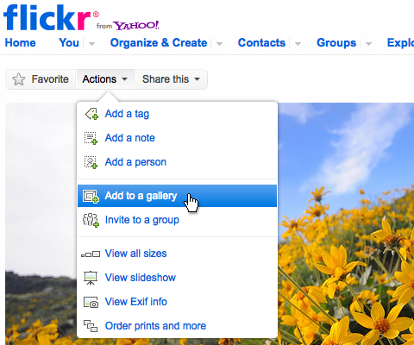

Comments
Users can comment on each other's photos, which is a fun and easy way to communicate.

Step 1
Click on the photo or gallery to add a comment. Then, scroll to the bottom of the page until the comment box appears.

Step 2
Type the comment into the box. Once finished, click Post Comment.

Profiles
Users can choose to share information about themselves, such as age, geographic location, interests, favorite movies, etc.

Step 1
To edit a profile, click the dropdown arrow next to You at the top of the page and then select Your Profile.

Step 2
On the right side of the next page, select Edit your profile information.

Step 3
There are a number of categories of information that can be changed on this page. Enter the information desired and then click SAVE IT at the bottom of the page.

Step 4
A user’s buddy icon can also be changed by using the menu on the right side of the screen seen after clicking on Your Profile. To do so, click Edit your buddy icon.
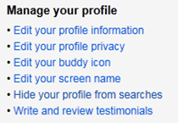

Step 5
On the page this link goes to, click Browse to find a picture and then click Upload or select a picture from your Flickr photos or from the web.

Contacts
Users can create their own personal network on Flickr, enabling them to keep in contact with specific people who share similar interests.

Step 1
To find friends or add contacts, click the Contacts link at the top of the page. On the right side of the screen, two options are given. To use an email account in order to add contacts click on Find Your Friends.

Step 2
Follow the steps in the Import your contacts window on your page. A number of different website accounts can be used to find friends who use Flickr.

Step 3
To find friends using a name, type the name into the text box under Find a person. Then, click Search.

Step 4
Once a friend has been located using the search field, click add as contact to the right of the person’s name.

Step 5
A window will then appear that allows the user to add the individual as a friend or as family. Select the desired options and click Add Contact.

Step 6
To view a list of contacts, click the dropdown arrow next to Contacts at the top of the screen and select Contact List.

Tags
Flickr allows users to describe the content of their photos with a list of keywords--called tags. Clicking on a tag takes users to all photos sharing the same tag, thus enabling a user-generated classification of content, also called a folksonomy.

Step 1
To add a tag to a particular picture, click on it and click add a tag under the Tags area on the right hand side of the screen.

Step 2
Enter the phrase desired into the box that appears. Then, click ADD.
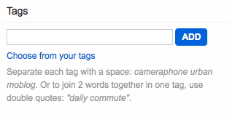

Step 3
Once tags have been added, it can be clicked on in order to find pictures with the same tags. Then, on the next screen, click See all public content tagged with _____ substituting the blank with the tag that has been selected.

Groups
Users can also create or join theme-based photo pools with corresponding discussion lists. This enables more in-depth discussion on topics of shared interest.

Step 1
To join a group, click Groups at the top bar of the page.

Step 2
On the right side of the screen, there is an option to either search for groups or create your own group. To search for a group, type a phrase into the box and click SEARCH.
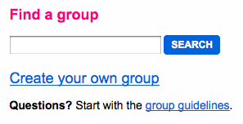

Step 3
To join a group, click Join? next to the group itself.

Step 4
To create a group, click Create your own group in the right hand corner of the Groups page.

Step 5
Select the kind of group desired, either Public, Public – Invitation only, or Private. Click Create under the type of group.
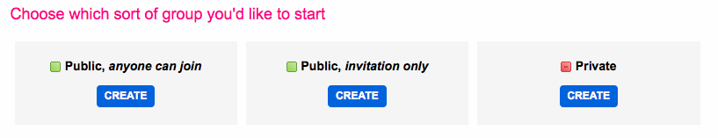

Step 6
Continue with the on screen instructions in order to create a group. Click Next to go on to the next page and then ALL DONE on the last screen. Then, rules, appearance, and other settings can be changed on the following screen as needed.

More Information
For access to additional information, tutorials and workshops, please visit the Center for Academic Technology website, http://www.butler.edu/it/cat, contact any Center for Academic Technology staff member at training@butler.edu, or contact the Information Commons desk in Irwin Library at infocommons@butler.edu or 940-9235.

Bibliography
www.flickr.com

Creative Commons Licensing
This quick guide is licensed under a Creative Commons Attribution-Noncommercial-Share Alike 3.0 United States License.

