Kinesiologic Analysis of the

CHIN-UP

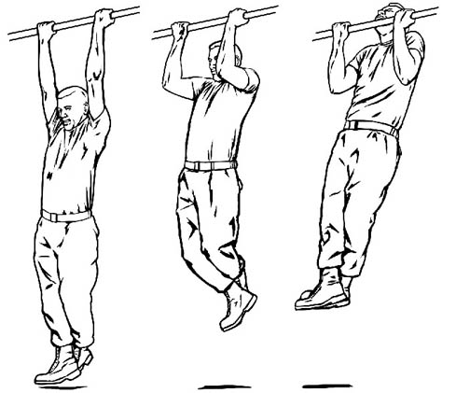

Kyle Lees  
8 December 2011  
PE 323  
Kinesiologic Analysis

Description of the Chin-Up

There are many great upper body workouts to improve your strength, but a chin-up is one of the best. When completing a chin-up, one will work their arms (biceps) and their back muscles tremendously. A chin-up involves grabbing a stable bar above your head and pulling yourself up so that your chine goes above the bar. The person is essentially fighting against gravity.

There are five steps to the chin-up, which are described in full detail further on in this report. The first step is the starting position, which is crucial to your success of a chin-up. You want to get your body in the best position possible to use the right form. The second movement is bringing your body up with the strength of your upper body. The third step, which is the hardest, is pulling your chin over the bar. This is where the chin-up gets its name. It is crucial to pull your chin over the bar to get the best possible results. The fourth step is pulling yourself back down. It is important to continue using great form on this step, because on the fifth step, you will be back in the starting position. You want to be sure you are in the best position possible when you get back to the starting position, with you body as vertical as it can be.  
 Those are the five steps of a chin-up. Typically, one will do as many reps as they can do without stopping. One can do chin-ups at a gym, but it is easy to find home equipment to perform a chin-up. In fact, one can be creative with where they use a chin-up, like a tree branch, but you must make sure it is stable and safe! Remember this is just one type of upper body workout, and there are many other great workouts to do. However, if you are in need of a quick upper body workout, just find a bar and pull yourself up!

Movement # 1 (The Starting Position)



To begin the chin-up, place your body underneath the center of the bar. With your forearm supinated, jump up and grip the bar with a cylindrical grip. Your arms should be fully extended with your feet dangling below. Cross your feet and get ready to pull yourself up.

Movement #2 (Pulling Yourself Up)  


After you have placed yourself in the starting position, propel yourself up. Your arms and trunk/back muscles will lift your body. Make sure your arms are at a 90-degree angle midway through the upper motion of the chin up. You will notice your knees will start to flex a little, but try to stay in an upright position as much as you can.

Movement #3 (Lifting Your Head Over the Bar)  


Getting your head over the bar and making sure your chin touches the bar is the toughest part of the chin-up. You will keep pulling your body up and you will have to extend your head back to make sure you get your chin over the bar. While you are doing this, your knees will start to extend back out.

Movement #4 (Pulling yourself back down)  


After you have pulled your chin over the bar, it is now time to pull yourself back down, toward the starting position. To do this, let the weight of your body pull yourself back toward the ground, but make sure you keep your cylindrical grip! Make sure your arms get back to a 90-degree angle, and once again your knees will start to bend.

Movement #5 (Back to the Starting Position)  


You are now back into the “starting position.” When you are here, your arms will be straight up in the air and your legs will be dangling below you. When you get here, you have completed one rep, and now it is time to see how many reps you can do. You should complete this cycle as many times as you can without letting go of the bar!!!

**Work Cited**

"Chin-Up." *National Strength and Conditioning Association*. NSCA. Web. 6 Dec. 2011. <http://www.nsca-lift.org/videos/Chin%20Up/defaultchinup.shtml>.

Picture

"How To - Do a Chin-Up | Healthy Living India." *HealthyLivingIndia.org - Healthy Living India Tells You How to Live Healthy | Healthy Recipes, Weight Loss, Fitness, Wellness | Health Blog India | India Health Blog*. Web. 06 Dec. 2011. <http://www.healthylivingindia.org/2011/01/how-to-do-a-chin-up.html>.