Image of a Learner
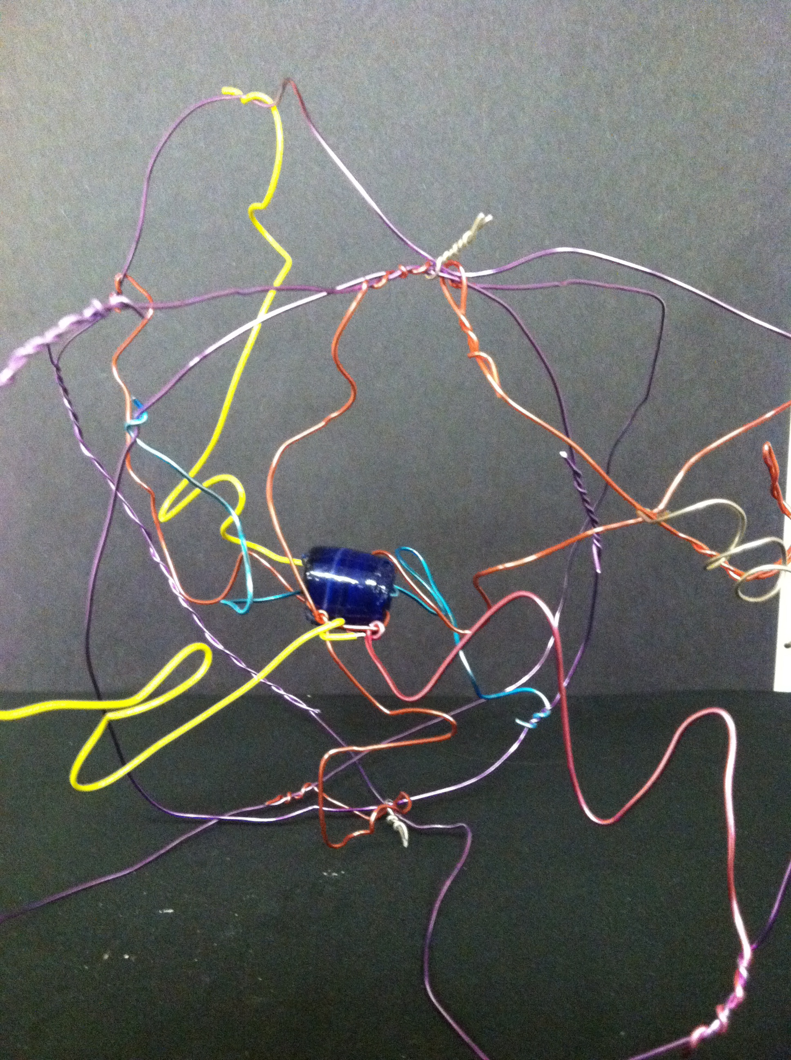
My image of a learner is a plasma globe (it looks like a ball of energy and when you touch it more lightning bolts come out of the middle). A plasma globe has all of this energy, but nowhere to go. Its electric feelers are constantly searching to connect and be guided to a direct path to the end of the globe. In the same way, learners are filled with energy and enthusiasm, but they need a passion to direct it toward. The teacher’s job then is to connect with the student and guide their enthusiasm toward a passion.
Similarly, the electric feelers can represent the way that learners crave a personal relationship with their teachers. It is not until the plasma globe is touched that it lights up and has more energy. Learners are the same way. They must connect with their teachers if they are going to succeed.
Learners also crave boundaries. If the hands do not guide the plasma globe, the electric feelers go every which way, and are not as bright. Students push teachers to find a limit, and teachers in response must set clear boundaries and expectation for their students so that they may focus their energy on the topic at hand.
Another aspect of the plasma globe is that it is made entirely of glass. The plasma globe is very delicate; if it receives the slightest crack, it won’t work anymore. Learners, especially adolescent learners, are fragile. They are very concerned with themselves during this time, and their egos can be easily destroyed by the slightest crack at them. The teacher must be careful not bring down her students with negative attitudes. Teachers hold a learner’s entire world in their hands. If they lose control for one second, the learner’s whole world could come crashing down right in front of them.

