**Break Even**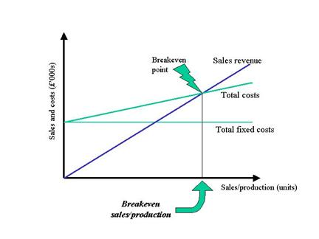

**Break Even Formulas:**

1) Break Even (units) = Fixed Costs / Contribution Margin per Unit

2) Break Even (sales) = Break Even (units) x Selling Price per Unit

**Summer Fusion 2015 - Break Even Exercise**

**Mascot Koozie Business**

Facts: Assume that you have $500 in fixed costs for molds, initial advertising, etc. to start your business. Also assume that you charge $15 per Koozie, and your product cost $10, for a contribution margin of $5 per Koozie.

Questions - please supply answers to 1-4 and discuss # 5

1. What is the break even in terms of number of Koozies req’d and total revenue?
2. What happens to the break even points if you raise prices to $20 per Koozie?
3. What are the break even points if the price was $15 and your product cost rose to $13 instead of $10?

4) (Assume original $15 price, $10 COGS) If you decided to buy more advertising up front and spend $1,000 instead of $500, what are your new break even points?

5) For discussion: What have you learned about this business by examining its break even point? How do you feel about new vs. used equipment? Annual raises?